

NAME:

ALGORITHMICS UNIT 3

SAC 2: Algorithms (Weeks 5 to 10)

Outcome 2

Date of Completion: 5-9 May 2025

Reading Time: 5 minutes
Writing time: 55 minutes
TOTAL (60 minutes)

QUESTION AND ANSWER BOOK

Type | Number of  questions | Number of questions  to be answered | Number of marks
Short/Extended Response | 9 | 9 | 36
 |  | Total | 36

Materials supplied
Question and answer book of 11 pages
Materials permitted
Pens/Stationary and one Scientific Calculator permitted.

No Reference material permitted.

Instructions
Write your name in the space provided above on this page.
All written responses must be in English, point form is preferred.

Students are NOT permitted to bring mobile phones and/or any other unauthorised electronic devices into the test room.
1. Consider the following algorithm:

secret(x,n):
if x = 1:
return n
else:
return secret(x // 2, n + 1)

Note that a // b means integer division of a by b, i.e. how many times does b go into a.

9 // 2 = 4
6 // 2 = 3

(a) Find secret(35) showing your working clearly.

Question removed, missed type in the function call

(2 marks)

(b) Name the design pattern of this algorithm.
Recursive

(1 mark)

2. Sean has constructed an undirected graph to represent the social network in his school. Each node represents a person, and an edge between two nodes indicates they are friends. The weight of the edge indicates the number of years they have been friends.

He runs Prim’s algorithm multiple times, starting at each node. He compares the resulting outputs and notes there are many different results. Outline TWO possible explanations for this, showing clearly how one can be true without the other.

(4 marks)

Disconnected graphs

Multiple edge weights

Stating that multiple MSTs exist is not enough, the question tells you this

Up to 2m per explanation

3. Barbara has been given an arrangement of knights on a chessboard, and wants to see if they can be arranged in a particular way.

Original State Target State
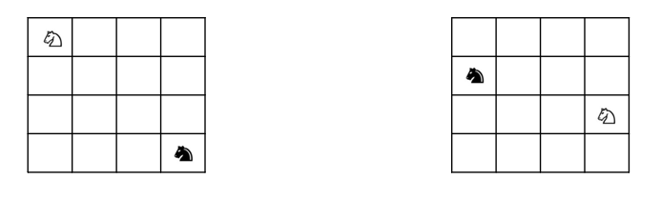

She creates a state tree based on the moves available at each previous state. Part of the tree is shown here:

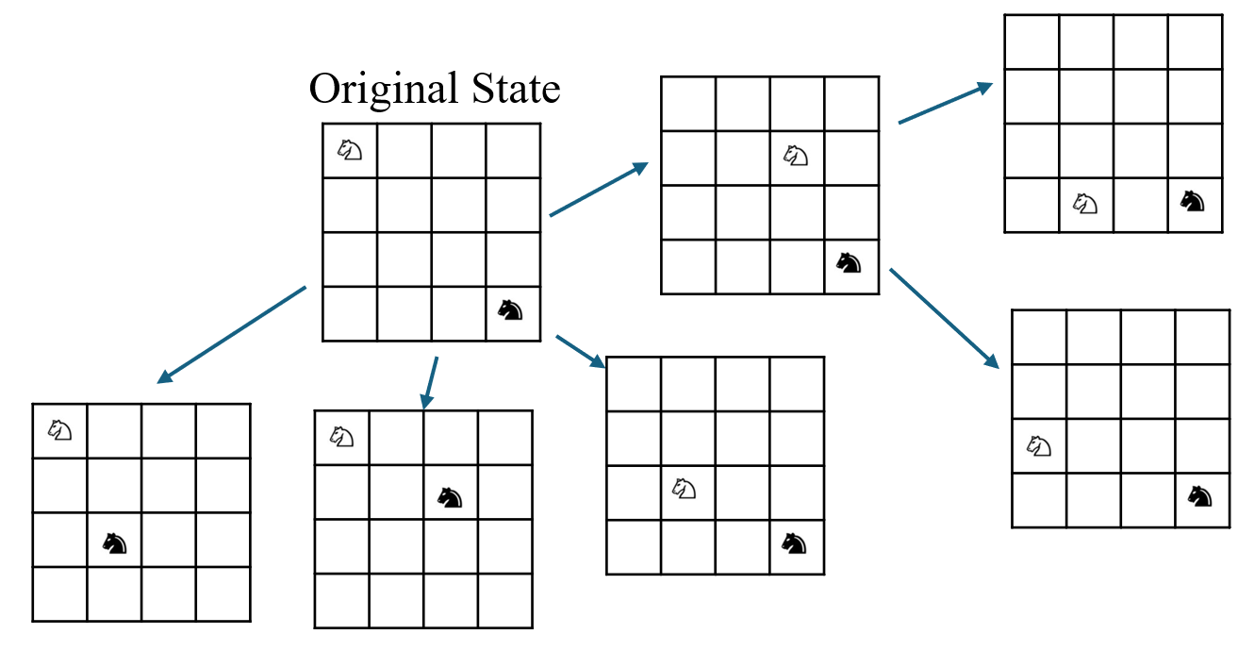

She wants to find the minimum number of moves required to reach the goal state.

Explain whether she should use breadth first search or depth first search to achieve this, giving three reasons why your choice is suitable and/or why the alternative is not suitable.

BFS

- Unweighted graph so number of iterations gives number of moves
- Small enough grid that BFS will make progress
- DFS could get lost down long paths
1m per explanation

(3 marks)

4. You are to design a brute force algorithm that looks for the word “cat” in a string of letters, and returns the position of the first letter, or -1 if not found. For example:

findcat(tacocatburrito) will return 4.
findcat(tacodogburrito) will return -1

(a) Write a function “checkcat” which takes a string and checks to see if the word “cat” appears starting at index n, returning True or False. For example:

checkcat(tacocatburrito,2) returns False

checkcat(tacocatburrito,4) returns True

def checkcat(string,index):
if string[index] = ‘c’ and string[index + 1] = ‘a’ and string[index + 2] = ‘t’:
return true
return false

(2 marks)

(b) Use your checkcat function to write the findcat algorithm.

def findcat(string):
for i between 0 and (length of string – 3):
if checkcat(string, i):
return i
return -1

(3 marks)

(c) Clive suggests using a divide and conquer approach to split the string into substrings and look for the word “cat” in each substring. Explain whether or not this would improve the time efficiency of your algorithm. (You do not need to provide a precise time complexity analysis.)

No
Still need to check all characters
Plus overhead of dividing etc.
Could also mention possibility of splitting ‘cat’ between strings though a correct D&C algorithm would account for this (and hence increase overhead)

5. Complete the tail-recursive algorithm below which takes a number x and raises it to a power y.

Power(x, y):
If y = 1:
Return x
Else:
/// YOUR CODE HERE ///

Return x * Power(x,y-1)

(2 marks)

6. A salesman is travelling between cities. Each city is modelled by a node. The edges between the cities represent the overall cost of travel, taking into account the profit he expects to make. For example, if the cost of travelling from A to B is $100, but he expects to make $90, then AB = 10. If the cost of travelling from B to C is $50 but he expects to make $100, then BC = -50.

He wants to work out which is the best city in which to set up his office, so that the average cost of travelling to each other city from that office is as low as possible.

The algorithm findRoutes(G,S) takes a graph G, starting vertex S, and returns an array containing the shortest distances to each of the nodes.

(a) Explain whether findRoutes should use Bellman Ford or Dijkstra.

Bellman Ford
Negative edges
(Note Dijkstra v modified controversy…)

(1 mark)

(b) Write an algorithm findOffice(G) which takes a graph G and returns the node with the lowest average distance/cost to all other nodes.

Def findOffice(G):
Mincost = infinity
Minnode = None

For each node in G:
Routes = findRoutes(G,node)
Ave = average cost of routes ** note don’t need ave
If ave < Mincost:
Mincost = ave
Minnode = node

Return Minnode

1m init
1m use findroutes
1m check
1m return (and all correct)

(4 marks)

7. Bruce is modelling the popularity of rides at a fairground. He noticed that people are more likely to visit rides that are adjacent to other rides, and wants to use this information to work out their popularity. He decides to use the PageRank algorithm on a graph where each ride is represented by a node, and a directed edge exists between two nodes if it is possible to go from one directly to the other.

(a) Explain what a damping factor of 0.7 means in the context of the real life scenario.

There is a 70% chance that the next ride someone visits will be adjacent to their current ride

1m mention prob
1m what it means in context

(2 marks)

(b) Use the PageRank algorithm to work out the rank of node C on the following graph after the second iteration. (The ‘initialisation’ phase does not count as an iteration). Show clear working. Use d = 0.7

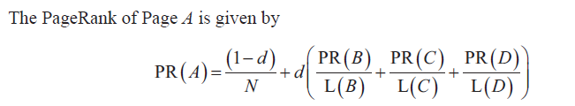
1m init to 1/3***
1m evidence of dummy edges
1m at least 1 correct calc
1m correct final answer

NB actual rank (i.e. 1st/2nd etc) not needed

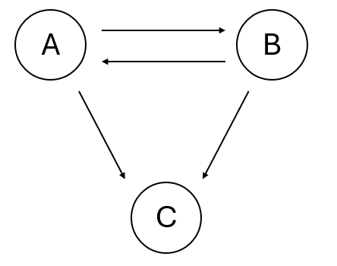

(4 marks)

8. Jennifer is researching her family tree. She has a large amount of data for the people in her village, and has used it to construct an undirected graph where each person is a node and an edge between two people indicates a parent-child relationship. She wants to use this information to add edges between any two people whose ancestry can be linked via those parent-child relationships.

(a) State the property of the graph she is trying to find, and state which algorithm she should use to find it.

Transitive closure
Floyd Warshall
(2 marks)

(b) After she has run her algorithm and added the edges, Bruno suggests that an edge between two people means that those people share a common ancestor (i.e. parent, grandparent, great grandparent etc.) Decide whether Bruno is correct/incorrect and give a proof of your answer. You can use words or diagrams to support your proof.
(2 marks)

Incorrect
Counterexample above – Child 1 and 2 would be linked in transitive closure but do not share common ancestors.
9. Doug wants to prove that a connected graph with n vertices and n-1 edges is always a tree. He aims to do this using proof by contradiction.

(a) What assumption will he make in order to create a contradiction?

There exists a graph with n vertices and n-1 edges which is not a tree.
(Needed more than “a connected graph with n vertices and n-1 edges is not always a tree)

(1 mark)

(b) Instead he decides to carry out a proof by induction based on the number of vertices. Construct his proof below.

Base case:
V = 1
Hence E = V – 1 = 0
Single vertex no cycles tree

Assume true for V = K
So E = K – 1

Now V = K + 1 and E = K, i.e. add one edge and one vertex

To add the vertex, the single added edge must connect that vertex to the existing tree. This cannot create a cycle since we would need a further edge from the new vertex back to the tree.

Hence true for V = K + 1

Hence true for all graphs

1m base case
1m assumption
1m attempt at k+1
1m all correct

(4 marks)

